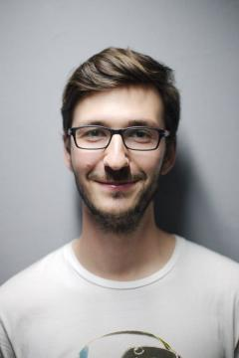

**Sun Yat-sen University | Accounting (Bachelor)**

Major: western economics, accounting computerization, financial management.

**2012.09-2016.06**

**Sun Yat-sen University | Accounting (Bachelor)**

Major: western economics, accounting computerization, financial management.

**2012.09-2016.06**

**Sun Yat-sen University | Accounting (Bachelor)**

Major: western economics, accounting computerization, financial management.

**2012.09-2016.06**

**EDUCATION**

Movies table tennis music photography reading

**HOBBIES**

**Master software**

InDesign

Photoshop

Illustrator

After effect

I’m familiar to related regulations and institutions, thus able to control the risk of bank operation.

Consequently my positive attitude and strong ability of learning led to my outstanding academic achievement.

HuangCun,Tianhe District, Guangzhou, Guangdong

3106XXXXX@qq.com

Personal

service@XXXX.me

Office

+86 135001XXXXX

Mobile

+61 135001XXXXX

Office

Being familiar with accounting theory

Mastering share option,futures and foreign currency hedge.

Mastering risk management.

Grasping balance sheet,cash flow report and other financial statements.

**Professional Skills**

**Bank of China**  **2015.07-2015.09**

**Customer service**

In the cases of which clients’ problems could not be solved online, transfer the information to the back staff to settle, and track the settlements before communicating with the clients.

**Bank of China**  **2015.07-2015.09**

**Customer service**

In the cases of which clients’ problems could not be solved online, transfer the information to the back staff to settle, and track the settlements before communicating with the clients.

**Bank of China**  **2015.07-2015.09**

**Customer service**

In the cases of which clients’ problems could not be solved online, transfer the information to the back staff to settle, and track the settlements before communicating with the clients.

**JOB EXPERIENCE**

Bangongziyuan

Objective: Bank Teller