I’m familiar to related regulations and institutions, thus able to control the risk of bank operation. Consequently my positive attitude and strong ability of learning led to my outstanding academic achievement.

ABOUT ME

**Bangong**

Objective: Bank Teller

**Sun Yat-sen University**  2012-2016

**Accounting**

Western economics, accounting computerization, marketing, intermediate financial accounting, advanced financial accounting, international finance.

EDUCATION

**Sun Yat-sen University**  2012-2016

**Accounting**

Western economics, accounting computerization, marketing, intermediate financial accounting, advanced financial accounting, international finance.

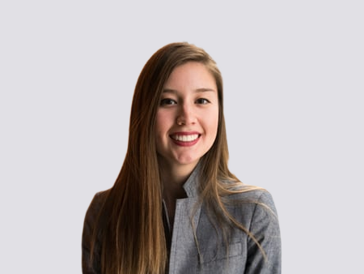

Personal skills

Graphic Design

UI/UX Design

Web Design

SEO

Photoshop

Illustrator

HTML 3

CSS 3

**Wubaidding**

Mobile phone resume

Contact

PHONE

EMAIL

WeChat

ADDRESS

1350013XXXXX

31XXXXX@qq.com

XXXXXX

GUANGZHOU

**Bank of China** 2015-2016

**Customer service**

Providing custom service including 7*24 financial consultations, trading assistants, Q&As and customer cares through telephone and internet.Abiding the regulations and working closely with the operating administration and other co-workers.

WORK EXPERIENCE

**Bank of China** 2015-2016

**Customer service**

Providing custom service including 7*24 financial consultations, trading assistants, Q&As and customer cares through telephone and internet.Abiding the regulations and working closely with the operating administration and other co-workers.

**Bank of China** 2015-2016

**Customer service**

Providing custom service including 7*24 financial consultations, trading assistants, Q&As and customer cares through telephone and internet.Abiding the regulations and working closely with the operating administration and other co-workers.