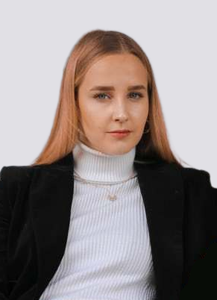

**2006-2008**

**Private University**

**Software Enginering**

Planar structure, three-dimensional composition, graphic creativity

**2006-2008**

**Private University**

**Web Design**

Planar structure, three-dimensional composition, graphic creativity

**2006-2008**

**Private University**

**Graphic Design**

Planar structure, three-dimensional composition, graphic creativity

service@XXXX.me

www.XXXX.me

+61 135001XXXX

Guangzhou Guangdong

Xiao Luo Bo

Web and Graphic Designer

**EDUCATION**

**EXPERIENCE**

**PERSONALQUALITIES**

**Attentiveness**

**Diplomatic**

**Analytical**

**Accountable**

**Dedication**

**Confidence**

**PROFESSIONAL SKILL**

**Worker Of the Year 2013**

Participate in the "Zhejiang TieMa Technology Co. Ltd." logo creative design

**Best Graphic Designer 2012**

Participate in the "Zhejiang TieMa Technology Co. Ltd." logo creative design

**AWARD**

**CSS**

**PHP**

**HTML**

**INDESIGN**

**PHOTOSHOP**

**ILLUSTRATOR**

**About me:** a creative and dynamic mind, I am keen to participate in social practice and the quality of volunteer work and rigorous.

**2010-2011**

**UI Designer**

**Graphic Designer**

Put forward the idea of design, design enterprise or product logo.

**2014-2015**

**UI Designer**

**Creative Director**

Put forward the idea of design, design enterprise or product logo.

**2014-2015**

**UI Designer**

**Software Engineer**

Put forward the idea of design, design enterprise or product logo.

**2006-2008**

**UI Designer**

**Web Designer**

Put forward the idea of design, design enterprise or product logo.

**Mr Tufyal Choudhury**

**Law Lecturer, Durham University**

Law Lecturer, Durham University

Email: t.a.choudhury@durham.ac.uk

**Mr Tufyal Choudhury**

**Law Lecturer, Durham University**

Law Lecturer, Durham University

Email: t.a.choudhury@durham.ac.uk

**Mr Tufyal Choudhury**

**Law Lecturer, Durham University**

Law Lecturer, Durham University

Email: t.a.choudhury@durham.ac.uk

**REFFERENCE**