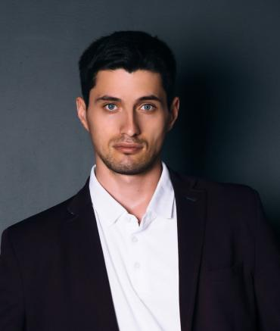

**PROFILE**

I’m familiar to related regulations and institutions, thus able to control the risk of bank operation. Consequently my positive attitude and strong ability of learning led to my outstanding academic achievement.

With a creative and dynamic mind, I’m keen on attending social practice and volunteer work with a quality of hardworking and rigor.

**Bangongziyuan** Objective: Bank Teller

**INFORMATION**

**EDUCATION**

Responsible

Organized

Cooperative

Learning

InDesign

Photoshop

Illustrator

After effect

**Skills**

**Birth date:**

August 10, 1989

**Gender:**

Male

**Political status:**

Masses

**Mobile:**

135001XXXX

**E-mail:**

service@XXXX.me

**Living place:**

Guangzhou, Guangdong

**Bank of China** SEP 2016-Present

**Customer service**

Providing custom service including 7*24 financial consultations, Quash and customer cares through telephone and internet.

**Bank of China** SEP 2016-Present

**Customer service**

Providing custom service including 7*24 financial consultations, Quash and customer cares through telephone and internet.

**Bank of China** SEP 2016-Present

**Customer service**

Providing custom service including 7*24 financial consultations, Quash and customer cares through telephone and internet.

**Bank of China** SEP 2016-Present

**Customer service**

Providing custom service including 7*24 financial consultations, Quash and customer cares through telephone and internet.

**EXPERIENCE**

**Sun Yassin University** SEP 2012-JUL 2015

**Accounting**

Intermediate financial accounting, cost accounting, management accounting, international finance.

**Sun Yassin University** SEP 2012-JUL 2015

**Accounting**

Intermediate financial accounting, cost accounting, management accounting, international finance.