**EDUCATION**

**Sun Yat-sen University | Accounting (Bachelor)**

2012.09-2016.06

Major: western economics, applied economics, accounting computerization, financial management, marketing, economic law, intermediate financial accounting, advanced financial accounting, cost accounting, management accounting, auditing, international finance.

**bangongziyuan**

AIRLINE STEWARDESS

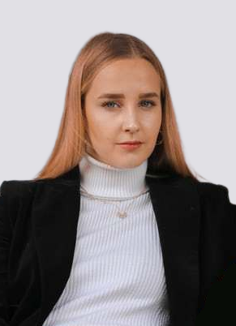

**Work experience**

**Bank of China | Customer service**

2015.07-2015.09

Providing custom service including 7*24 financial consultations, trading assistants, Q&As and customer cares through telephone and internet. In the cases of which clients’ problems could not be solved online, transfer the information to the back staff to settle, and track the settlements before communicating with the clients.

**Bank of China | Customer service**

2015.07-2015.09

Providing custom service including 7*24 financial consultations, trading assistants, Q&As and customer cares through telephone and internet. In the cases of which clients’ problems could not be solved online, transfer the information to the back staff to settle, and track the settlements before communicating with the clients.

**Bank of China | Customer service**

2015.07-2015.09

Providing custom service including 7*24 financial consultations, trading assistants, Q&As and customer cares through telephone and internet. In the cases of which clients’ problems could not be solved online, transfer the information to the back staff to settle, and track the settlements before communicating with the clients.

**PROFILE**

I’m familiar to related regulations and institutions, thus able to control the risk of bank operation.

With a creative and dynamic mind, I’m keen on attending social practice and volunteer work with a quality of hardworking and rigor.

I’m always honest by sticking to my promise and always willing to communicate with others or to help them with a great sense of teamwork.

**GET INTOUCH**

**Birthday:** August 10, 1989

**Mobile:** 135001XXXXX

**E-mail:** service@XXXXX.me

**Living place:** Guangzhou, Guangdong

**SPECIAL SKILLS**

PHOTOSHOP

ILLUSTRATOR

HTML & CSS

JAVA SCRIPT

Movies table tennis music

Travel photography reading

**HOBBIES**

**AWARDS AND CERTIFICATES**

**Awards:**

Awarded as the Excellent Student during the undergraduate period;

**Certificate:**

National Computer 2 level test, accountant qualification certificate, driver's license;

**SPECIAL SKILLS**

**Language Proficiency:**

Excellent reading and writing ability, good listening and speaking ability.

Chinese(fluent in Cantonese,Hakka and Putonghua)