Hi, I’m Social Media Strategist
Adept at working effectively to achieve goals both as a cross-functional team member and individual contributor. Fuga nequi cone nimendis as adigend Emolest, omnis rem et quate volorrum.
PROFILE
Accomplished business development leader offering over 16 years of experience driving revenue through building and maintaining client
relationships. Creative and dynamic marketer with proven expertise in
consistently penetrating new markets to ensure revenue growth.

PERSONAL DETAIL
NATASYA LEMIE
31st of June 1994
Single
Russian
EXPERIENCES
GEOGLE
Managing Director
2000-2014

Served as a key member of the executive team
charged with formulating strategic direction
and devising business development initiatives
consistent with overall strategy. Traveled
nationally to identify business opportunities
and effectively managed a territory spanning
across the United States and Canada.
Served as a key member of the executive team charged with formulating strategic direction and devising business development initiatives consistent with overall strategy. Travele nationally to identify business opportunities and effectively managed a territory spanning across the United States and Canada.

CONTACT
+00 000 000
201 City Name CN 000
info@example.com
www.example.com
YUHUU
Managing Director
2000-2014
INTEREST
REFERENCE
Mr John Doe
Senior Marketing
Dunia, Inc.
+444 000 0000
info@example.com

CORE COMPETENCIES
MARKETING
Ficae nis molupti tem
EDUCATION & COURSE
ECONOMIC
University of Orlando
2000-2014
Mr John Doe
Senior Marketing
Dunia, Inc.
+444 000 0000
info@example.com

SEO SPECIALIST
Ficae nis molupti tem
FINANCE COURSE
University of Orlando
2000-2014
MARKETING
Ficae nis molupti tem
NATASYA LEMIE
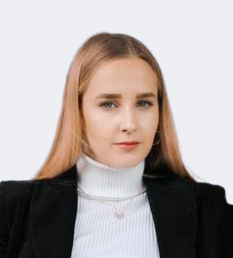
@XXX

