趣 味 英 语

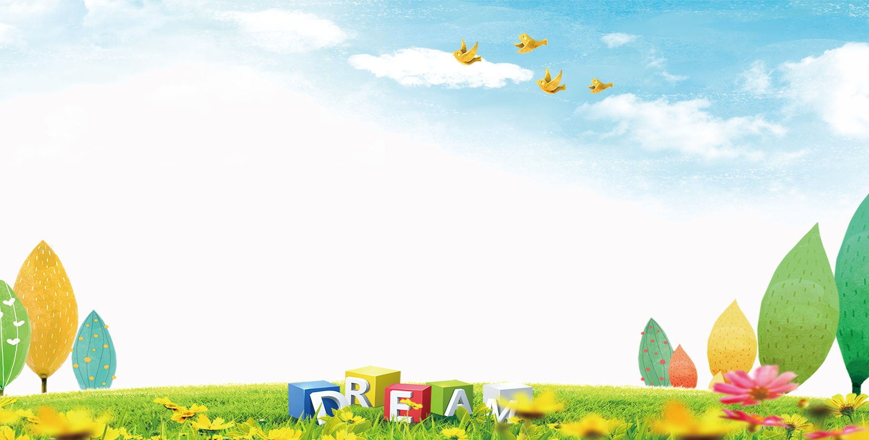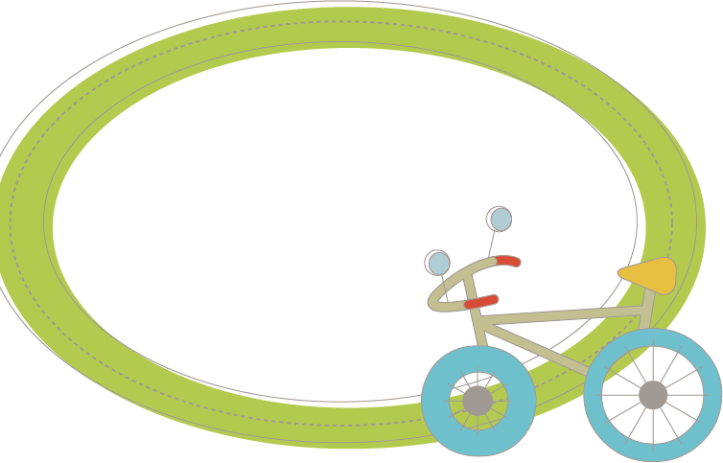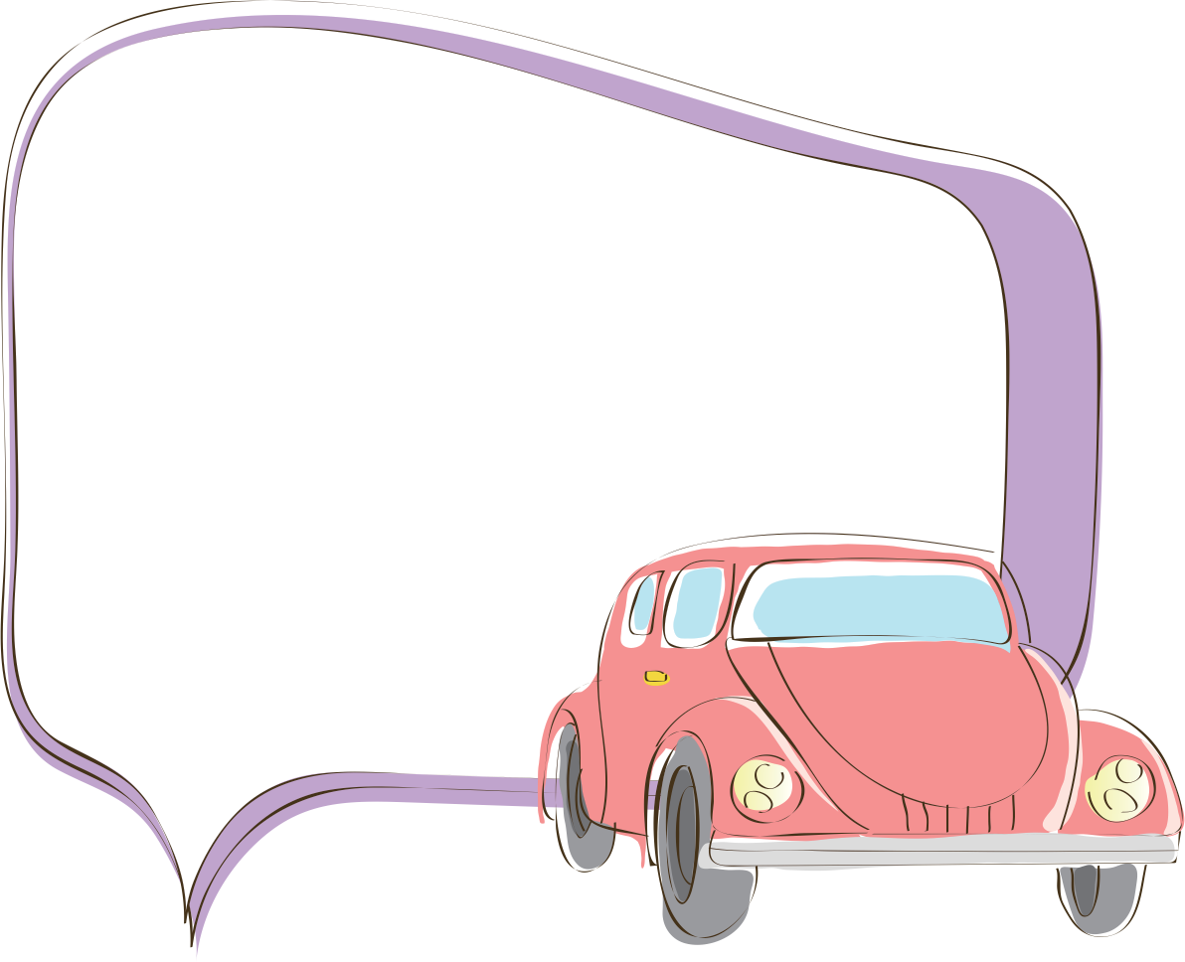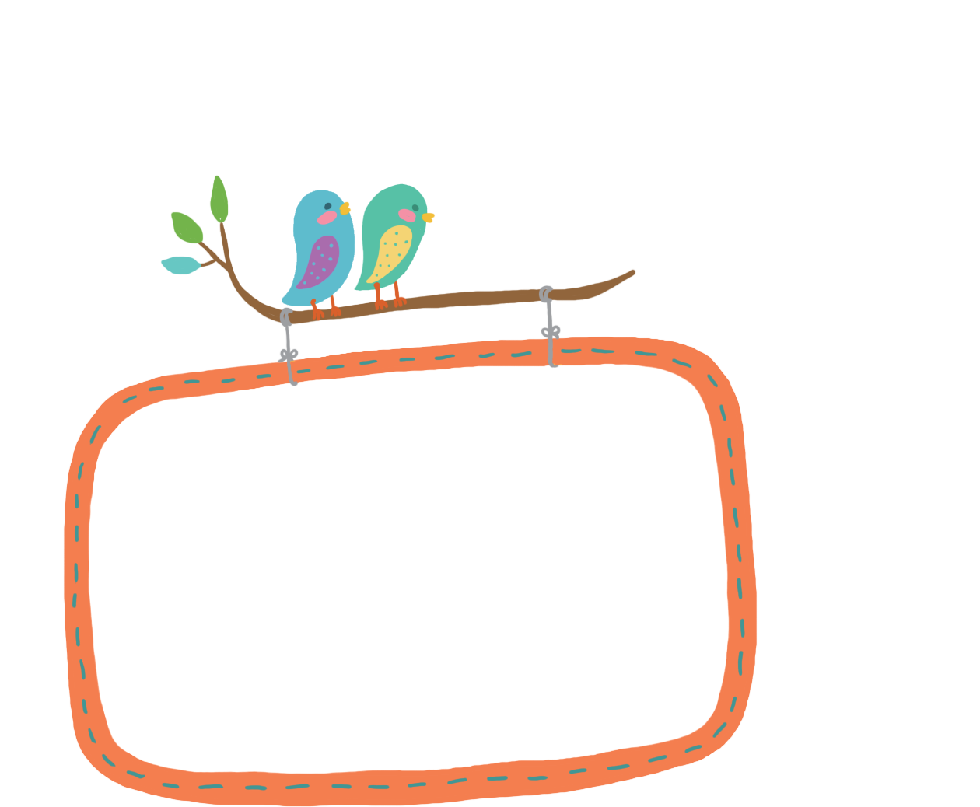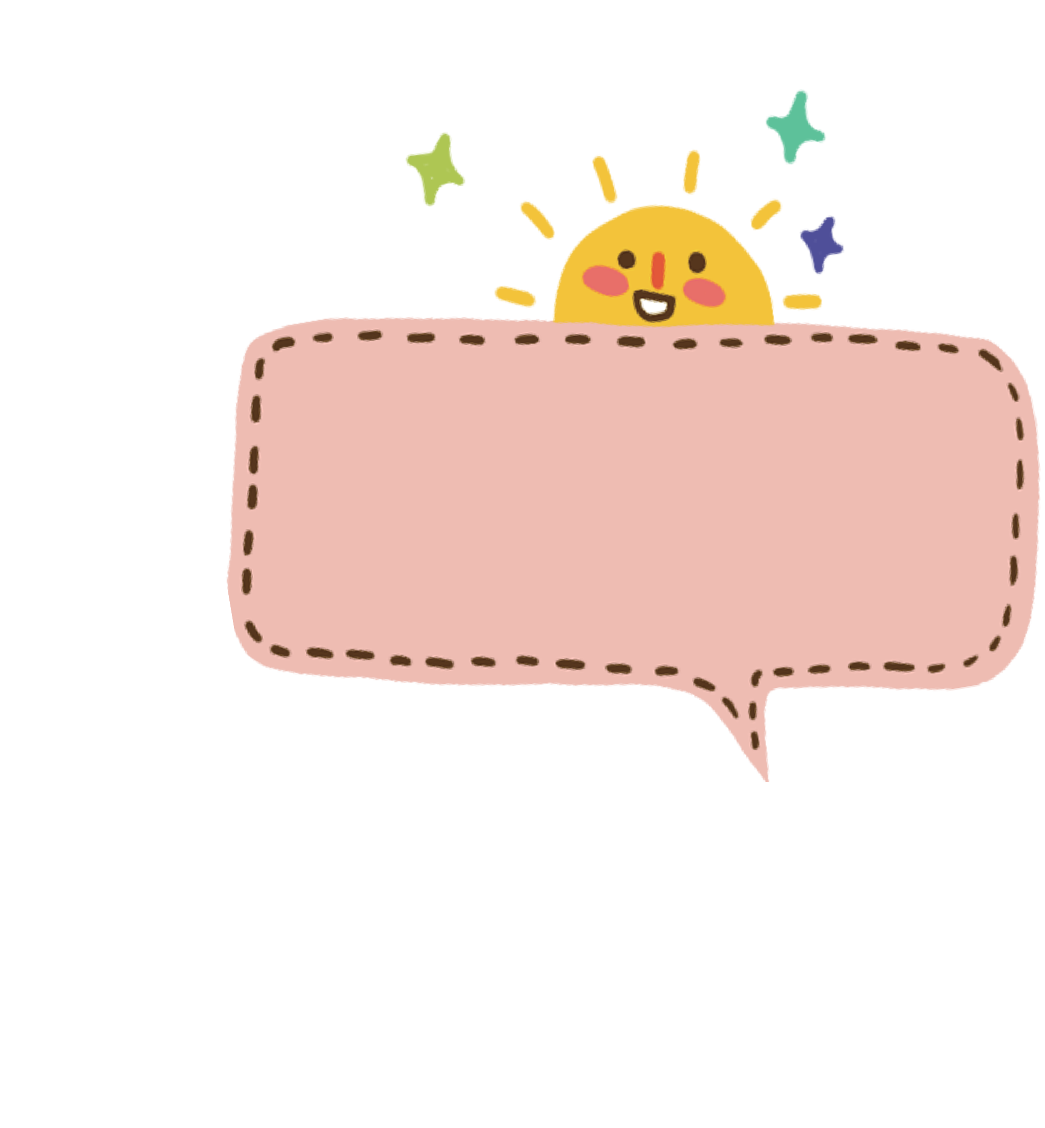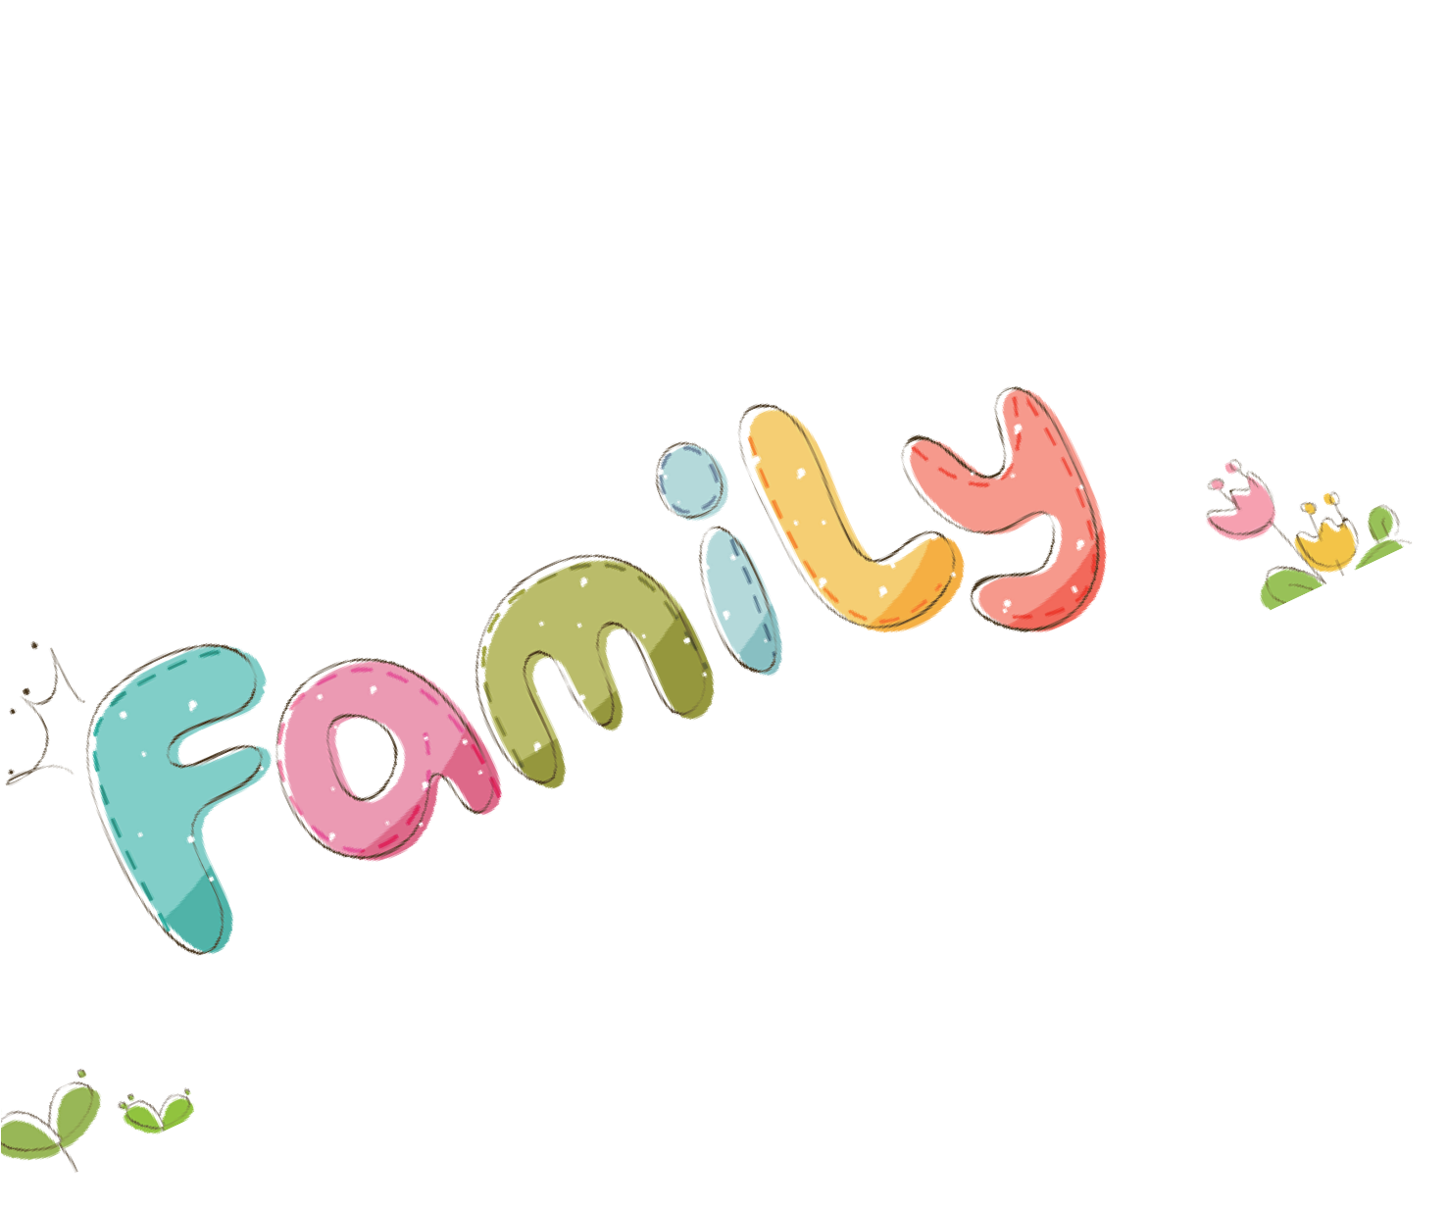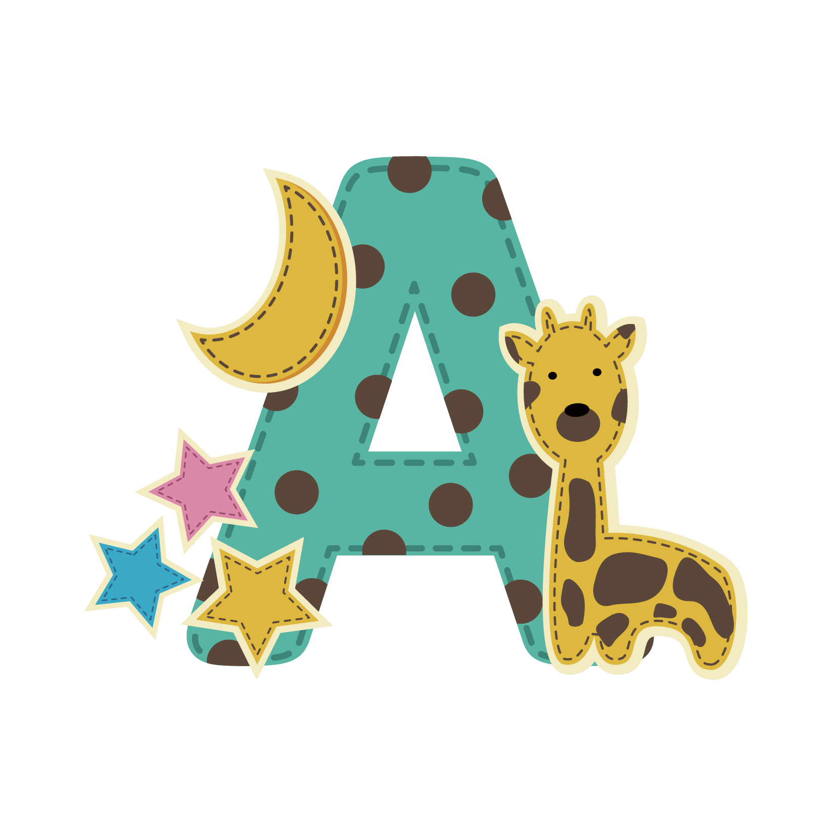

猜猜我是谁
I am black and white. I give milk.
我是黑白色的。我供给牛奶。
Guess who I am. It’s me, the cow!
猜猜我是谁。是我，奶牛！
I have a red comb. I lay eggs.
我有一个红色的鸡冠。我孵蛋。 Guess who I am. It’s me, the hen!猜猜我是谁。是我，母鸡！

滑冰
妈妈买了我一双冰鞋鞋子在我的第五个生日。 从那时起，我爱好滑冰。它不仅使我越来越加强，而且帮助我知道生活许多真谛。 我知道摔倒是正常的，并且，如果只有你能摔倒后再站起来，就是非常好!
Mom bought me a pair of skating shoes at my fifth birthday. From then on, I developed the hobby of skating. It not only makes me stronger and stronger, but also helps me know many truths of life. I know that it is normal to fall, and if only you can get on your feet again and keep on moving, you are very good!
自我介绍
To introduce myself（介绍我自己） Hello,every one!（大家好）
My name is **** . （我叫****）
I'm a 15 years old boy. （我是一个15岁的男孩）
I live in the beautiful city of Rizhao.（我住在美丽的Rizhao城）
I'm an active ,lovely and clever boy.(我是一个活跃的可爱的聪明的男孩）

Congratulations! 祝贺您！ Happy birthday! 生日快乐！ Happy new year! 新年快乐！ Merry Christmas! 圣诞快乐！ Have a nice holiday! 假日快乐！
Wish you every success! 祝您成功！

