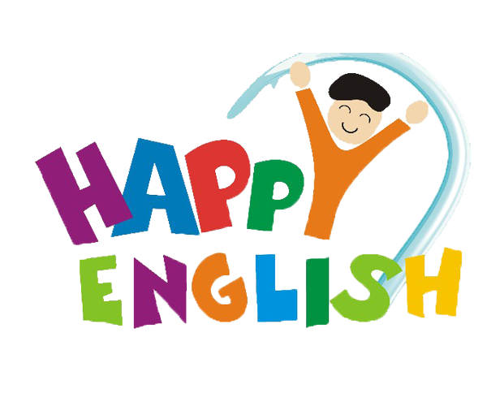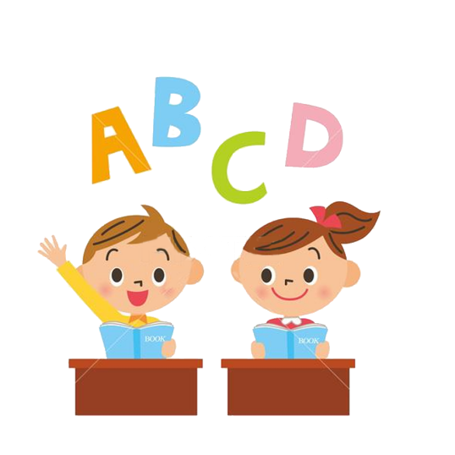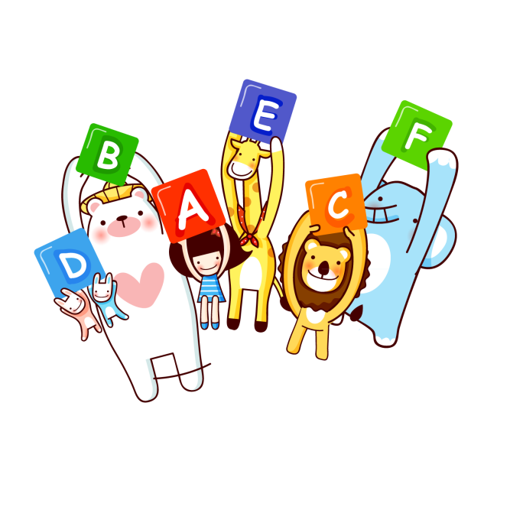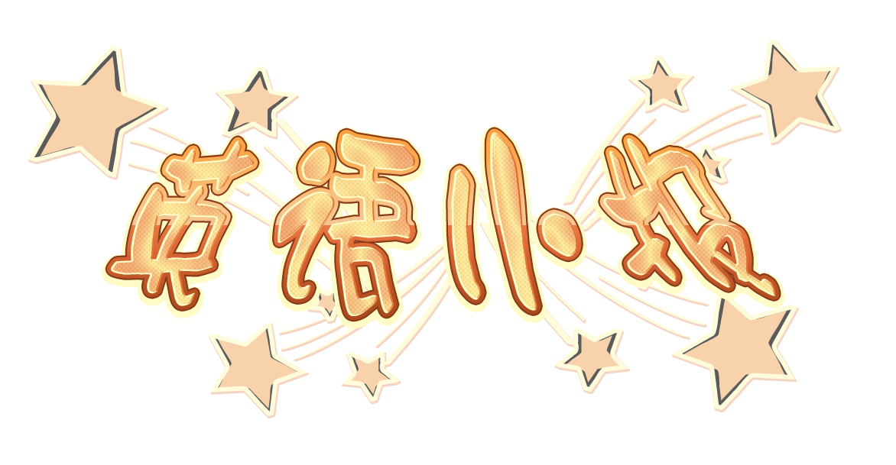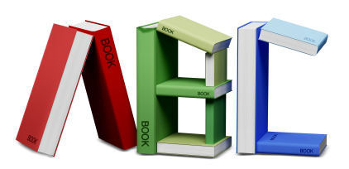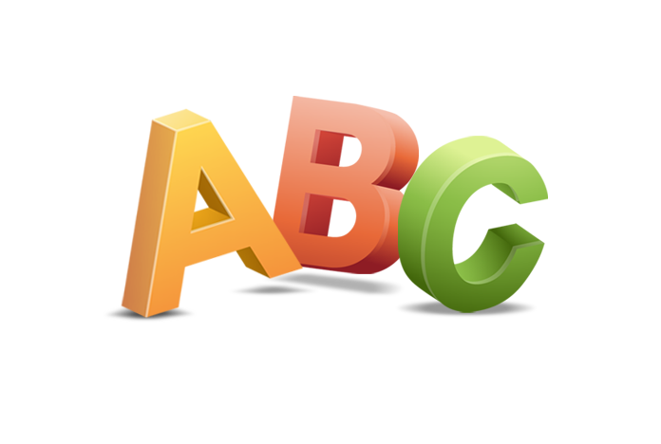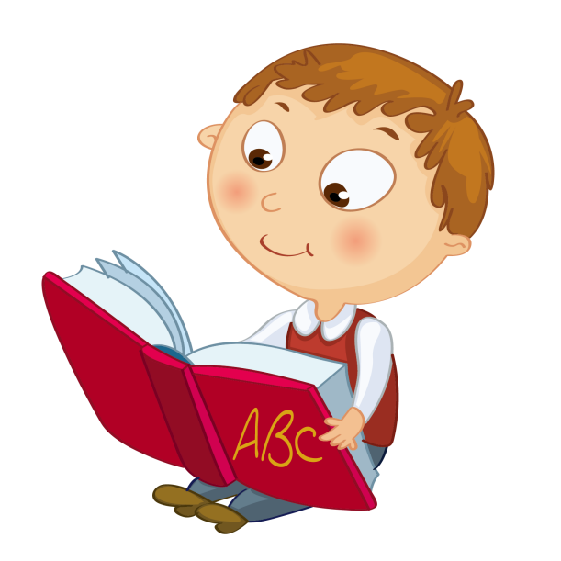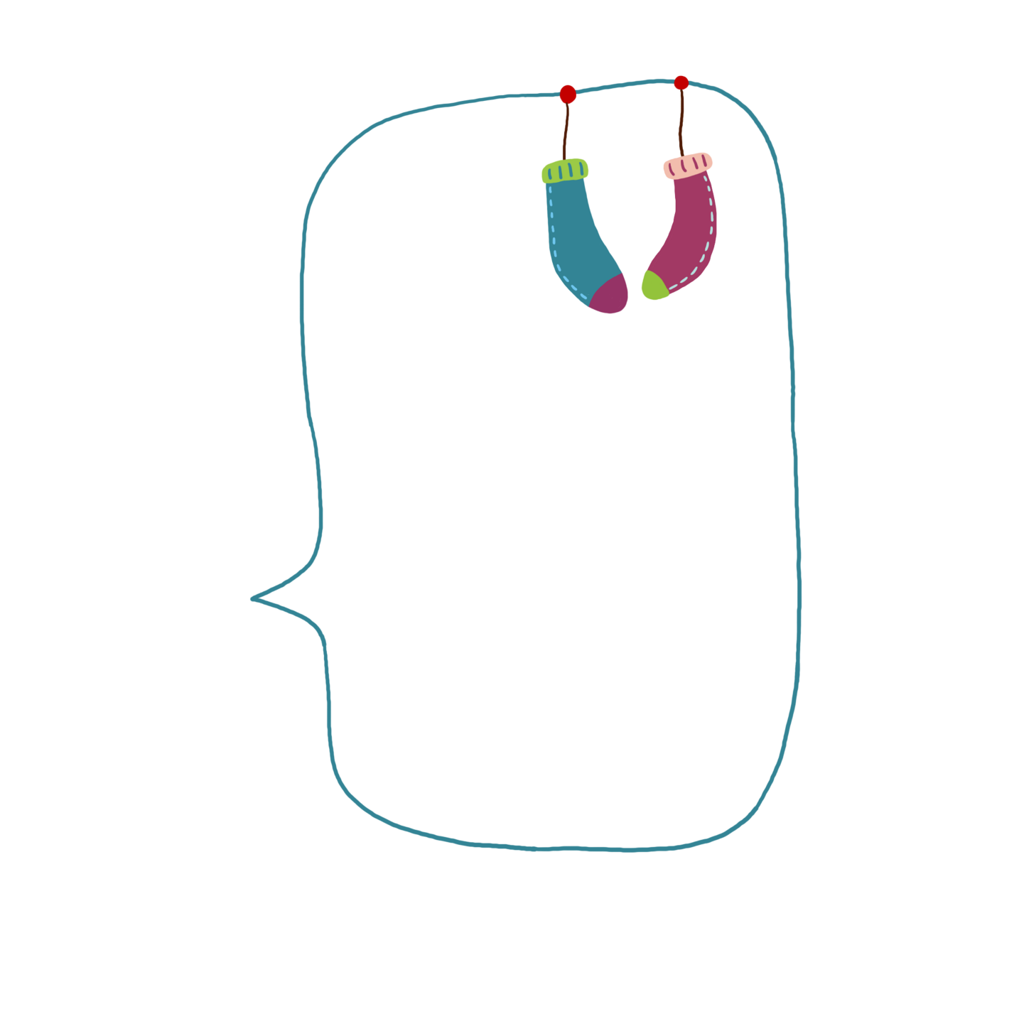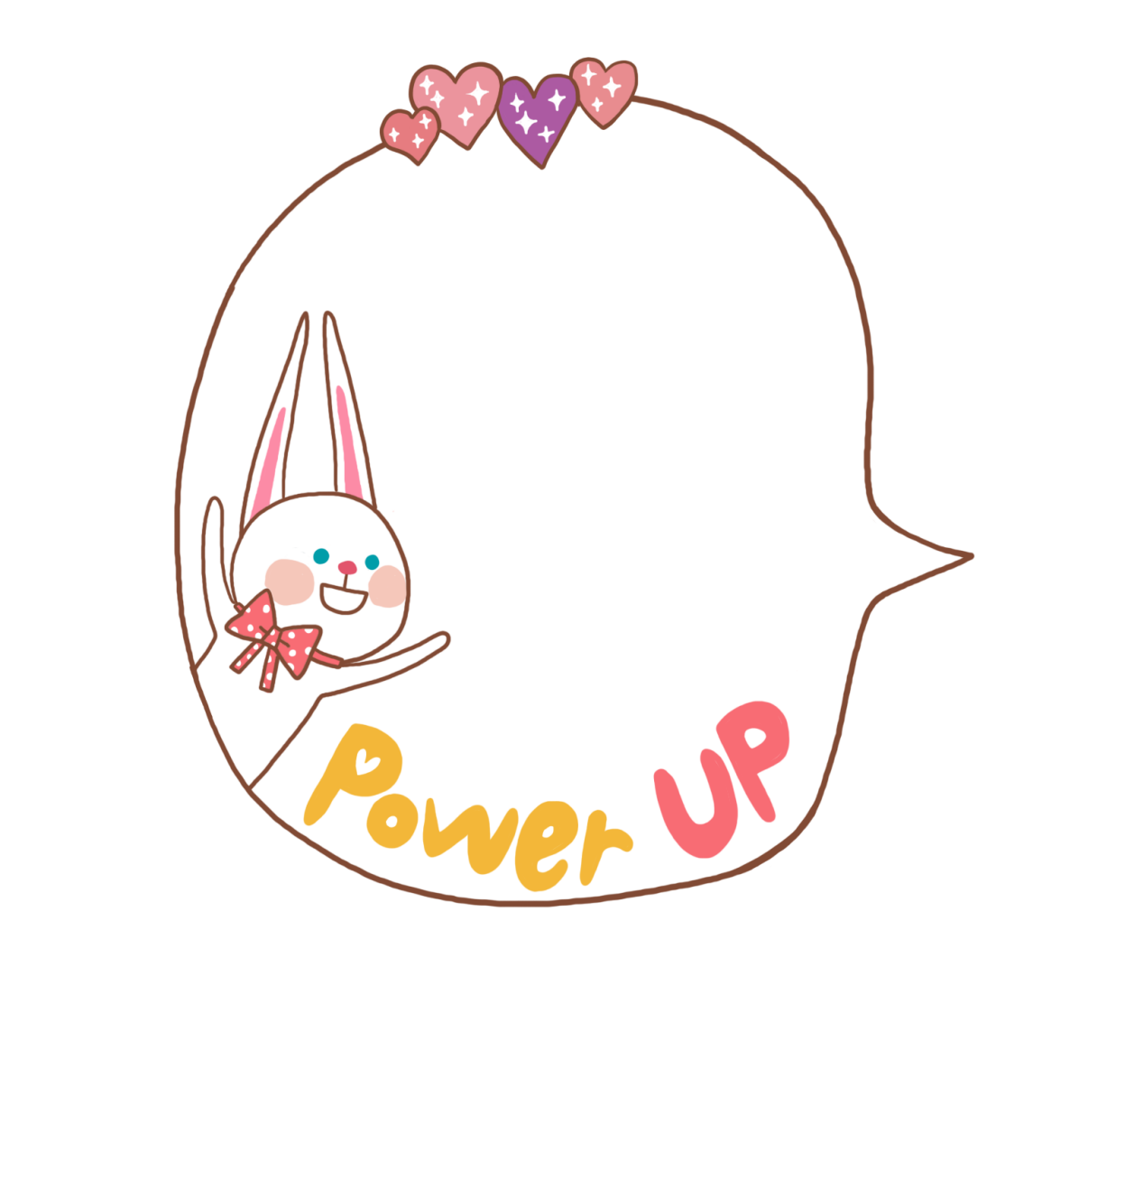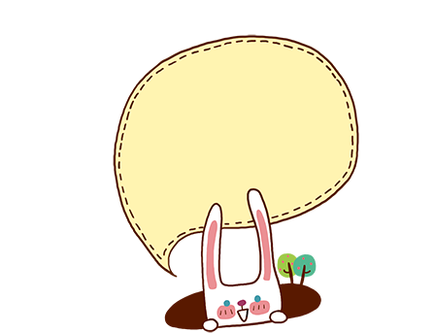

1. Do one thing at

a time, and do well.

一次只做一件事，做到最好！

2、Never forget to say “thanks”.

永远不要忘了说“谢谢”!

3、Keep on going never give up.

勇往直前， 决不放弃！

4、Whatever is worth doing is worth doing well.

任何值得做的事就值得把它做好！

5、Believe in yourself. 相信你自己！

6、I can because i think i can.

我行，因为我相信我行！

7、Action speak louder than words.

行动胜于言语！

8、Never say die. 永不气馁！

9、Never put off what you can do today until tomorrow. 今日事今日毕！

英语名言

Skating

Mom bought me a pair of skating shoes at my fifth birthday. From then on, I developed the hobby of skating. It not only makes me stronger and stronger, but also helps me know many truths of life. I know that it is

normal to fall, and if only you can get on your feet again and keep on moving, you are very good!

滑冰

妈妈买了我一双冰鞋鞋子在我的第五个生日。 从那时起，我爱好滑冰。 它不仅使我越来越加强，而且帮助

我知道生活许多真谛。 我知道摔倒是

就是非常好!

英语小短文

Congratulations!祝贺您！

Happy birthday!生日快乐！

Happy new year!新年快乐！

Merry Christmas!圣诞快乐！

Have a nice holiday!假日快乐！

Wish you every success!祝您成功!

英语常用祝贺语