趣味英语

自我介绍
To introduce myself（介绍我自己） Hello,every one!（大家好）
My name is **** . （我叫****）
I'm a 15 years old boy. （我是一个15岁的男孩）
I live in the beautiful city of Rizhao.（我住在美丽的Rizhao城）
I'm an active ,lovely and clever boy.(我是一个活跃的可爱的聪明的男孩）

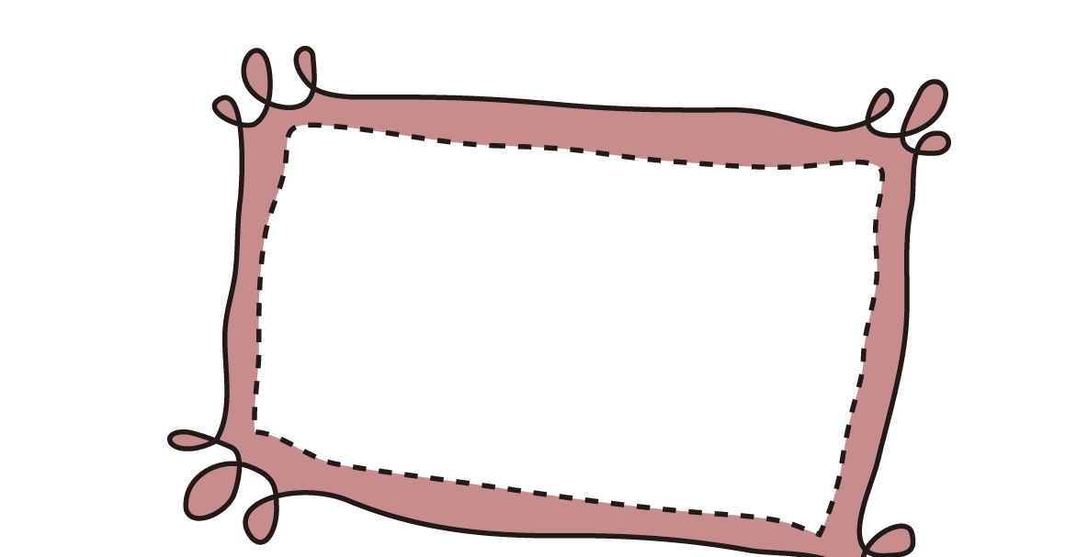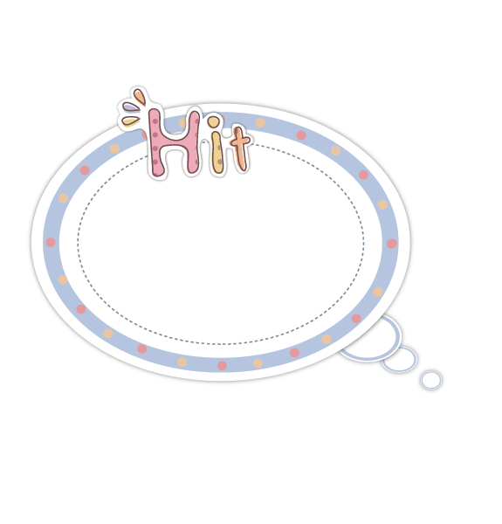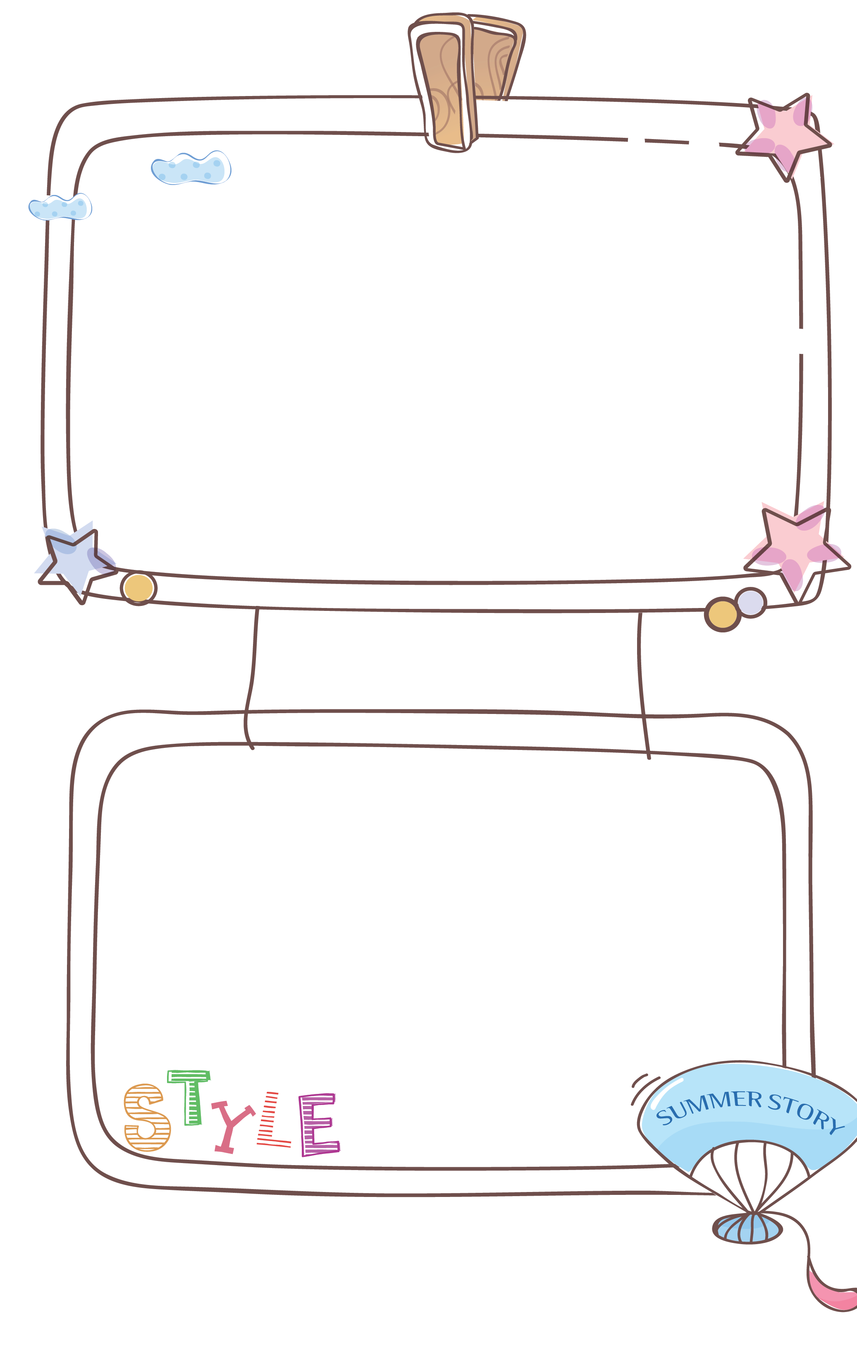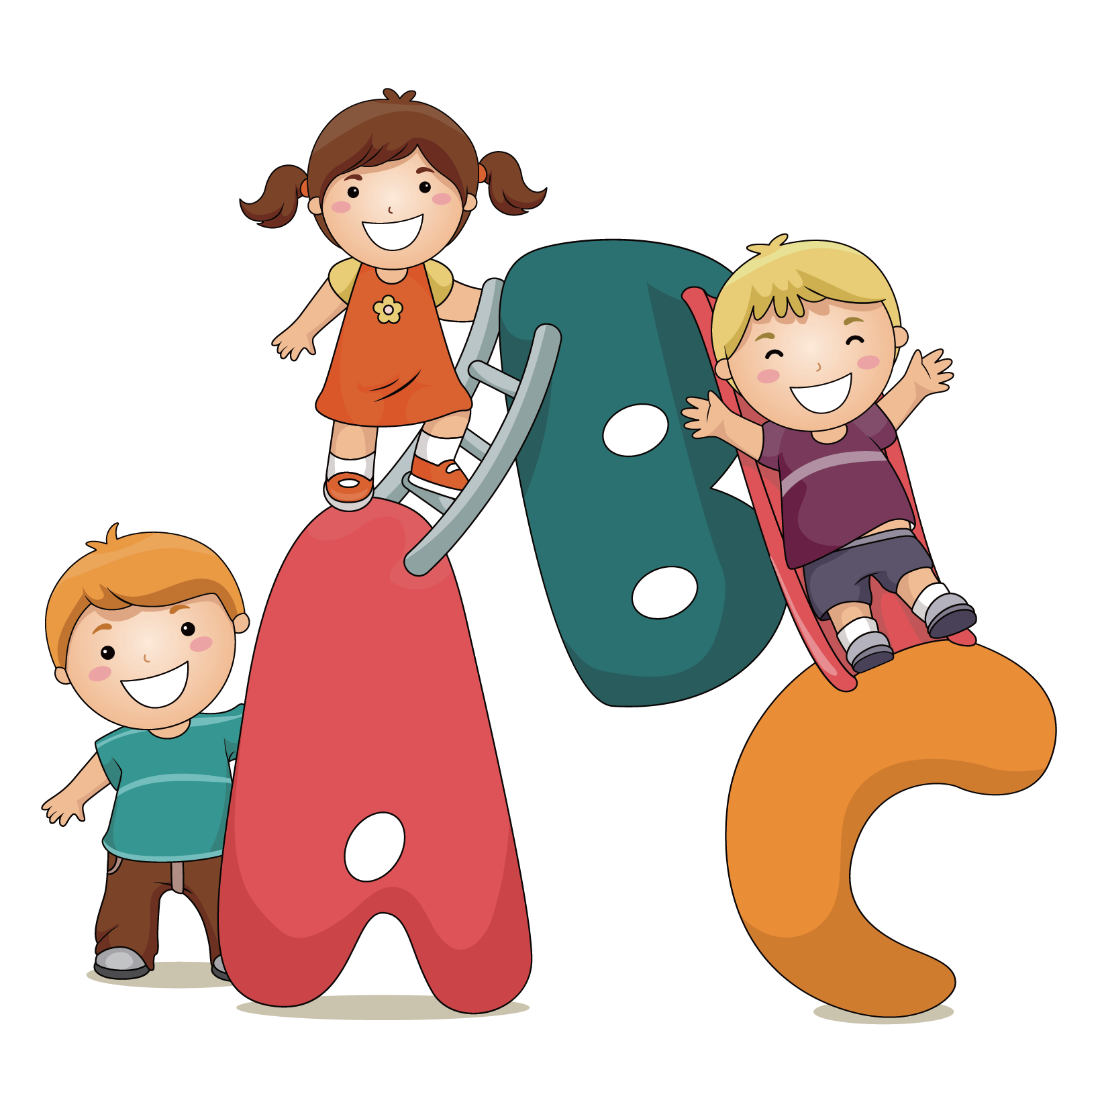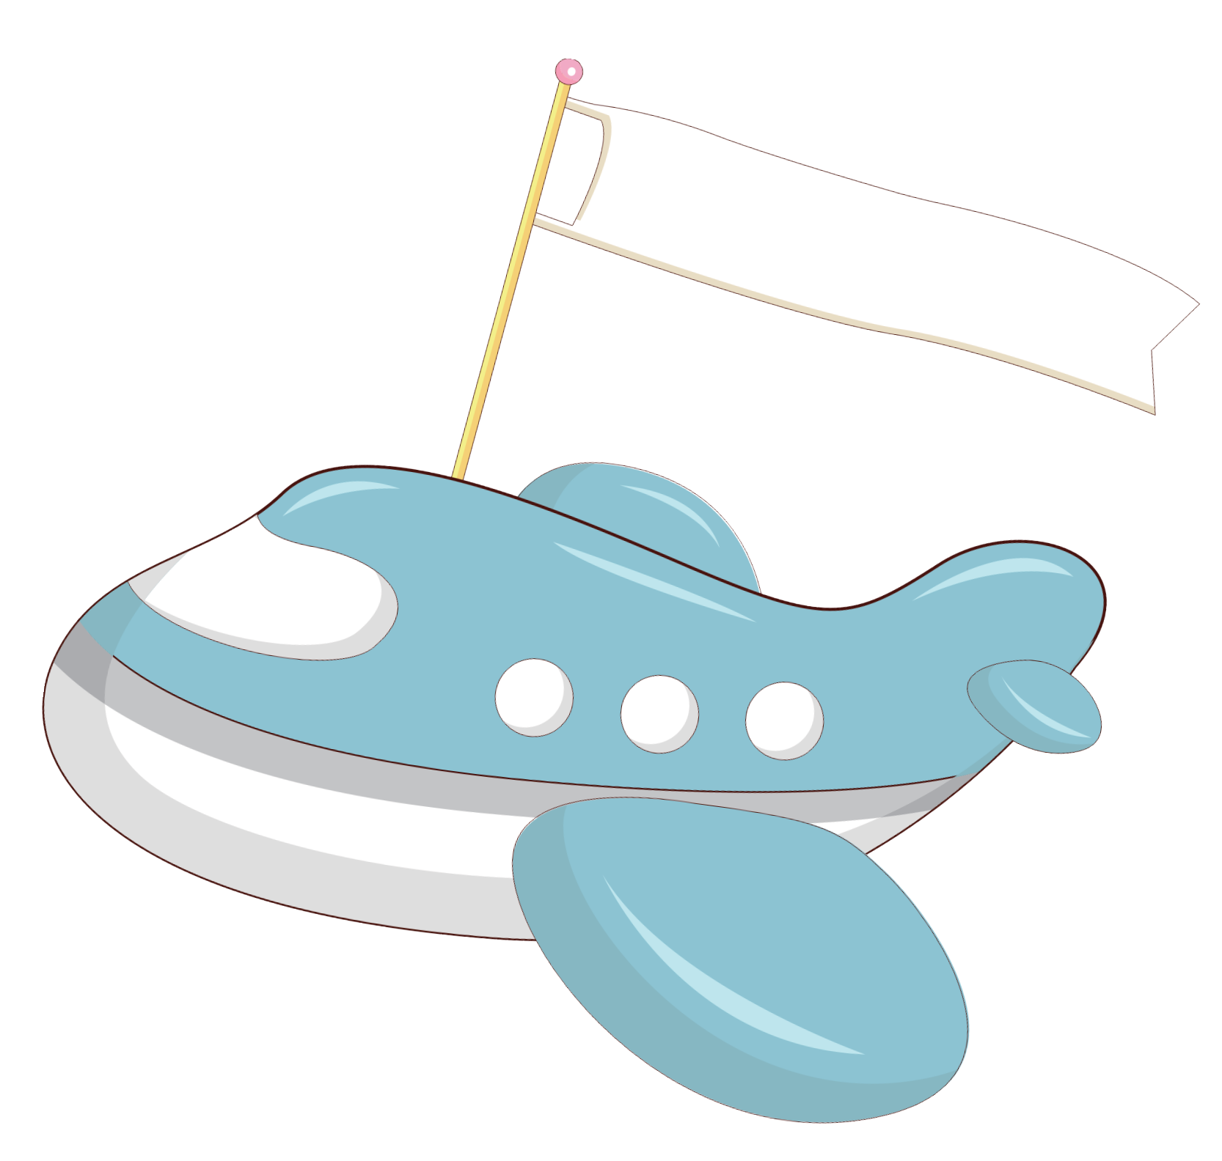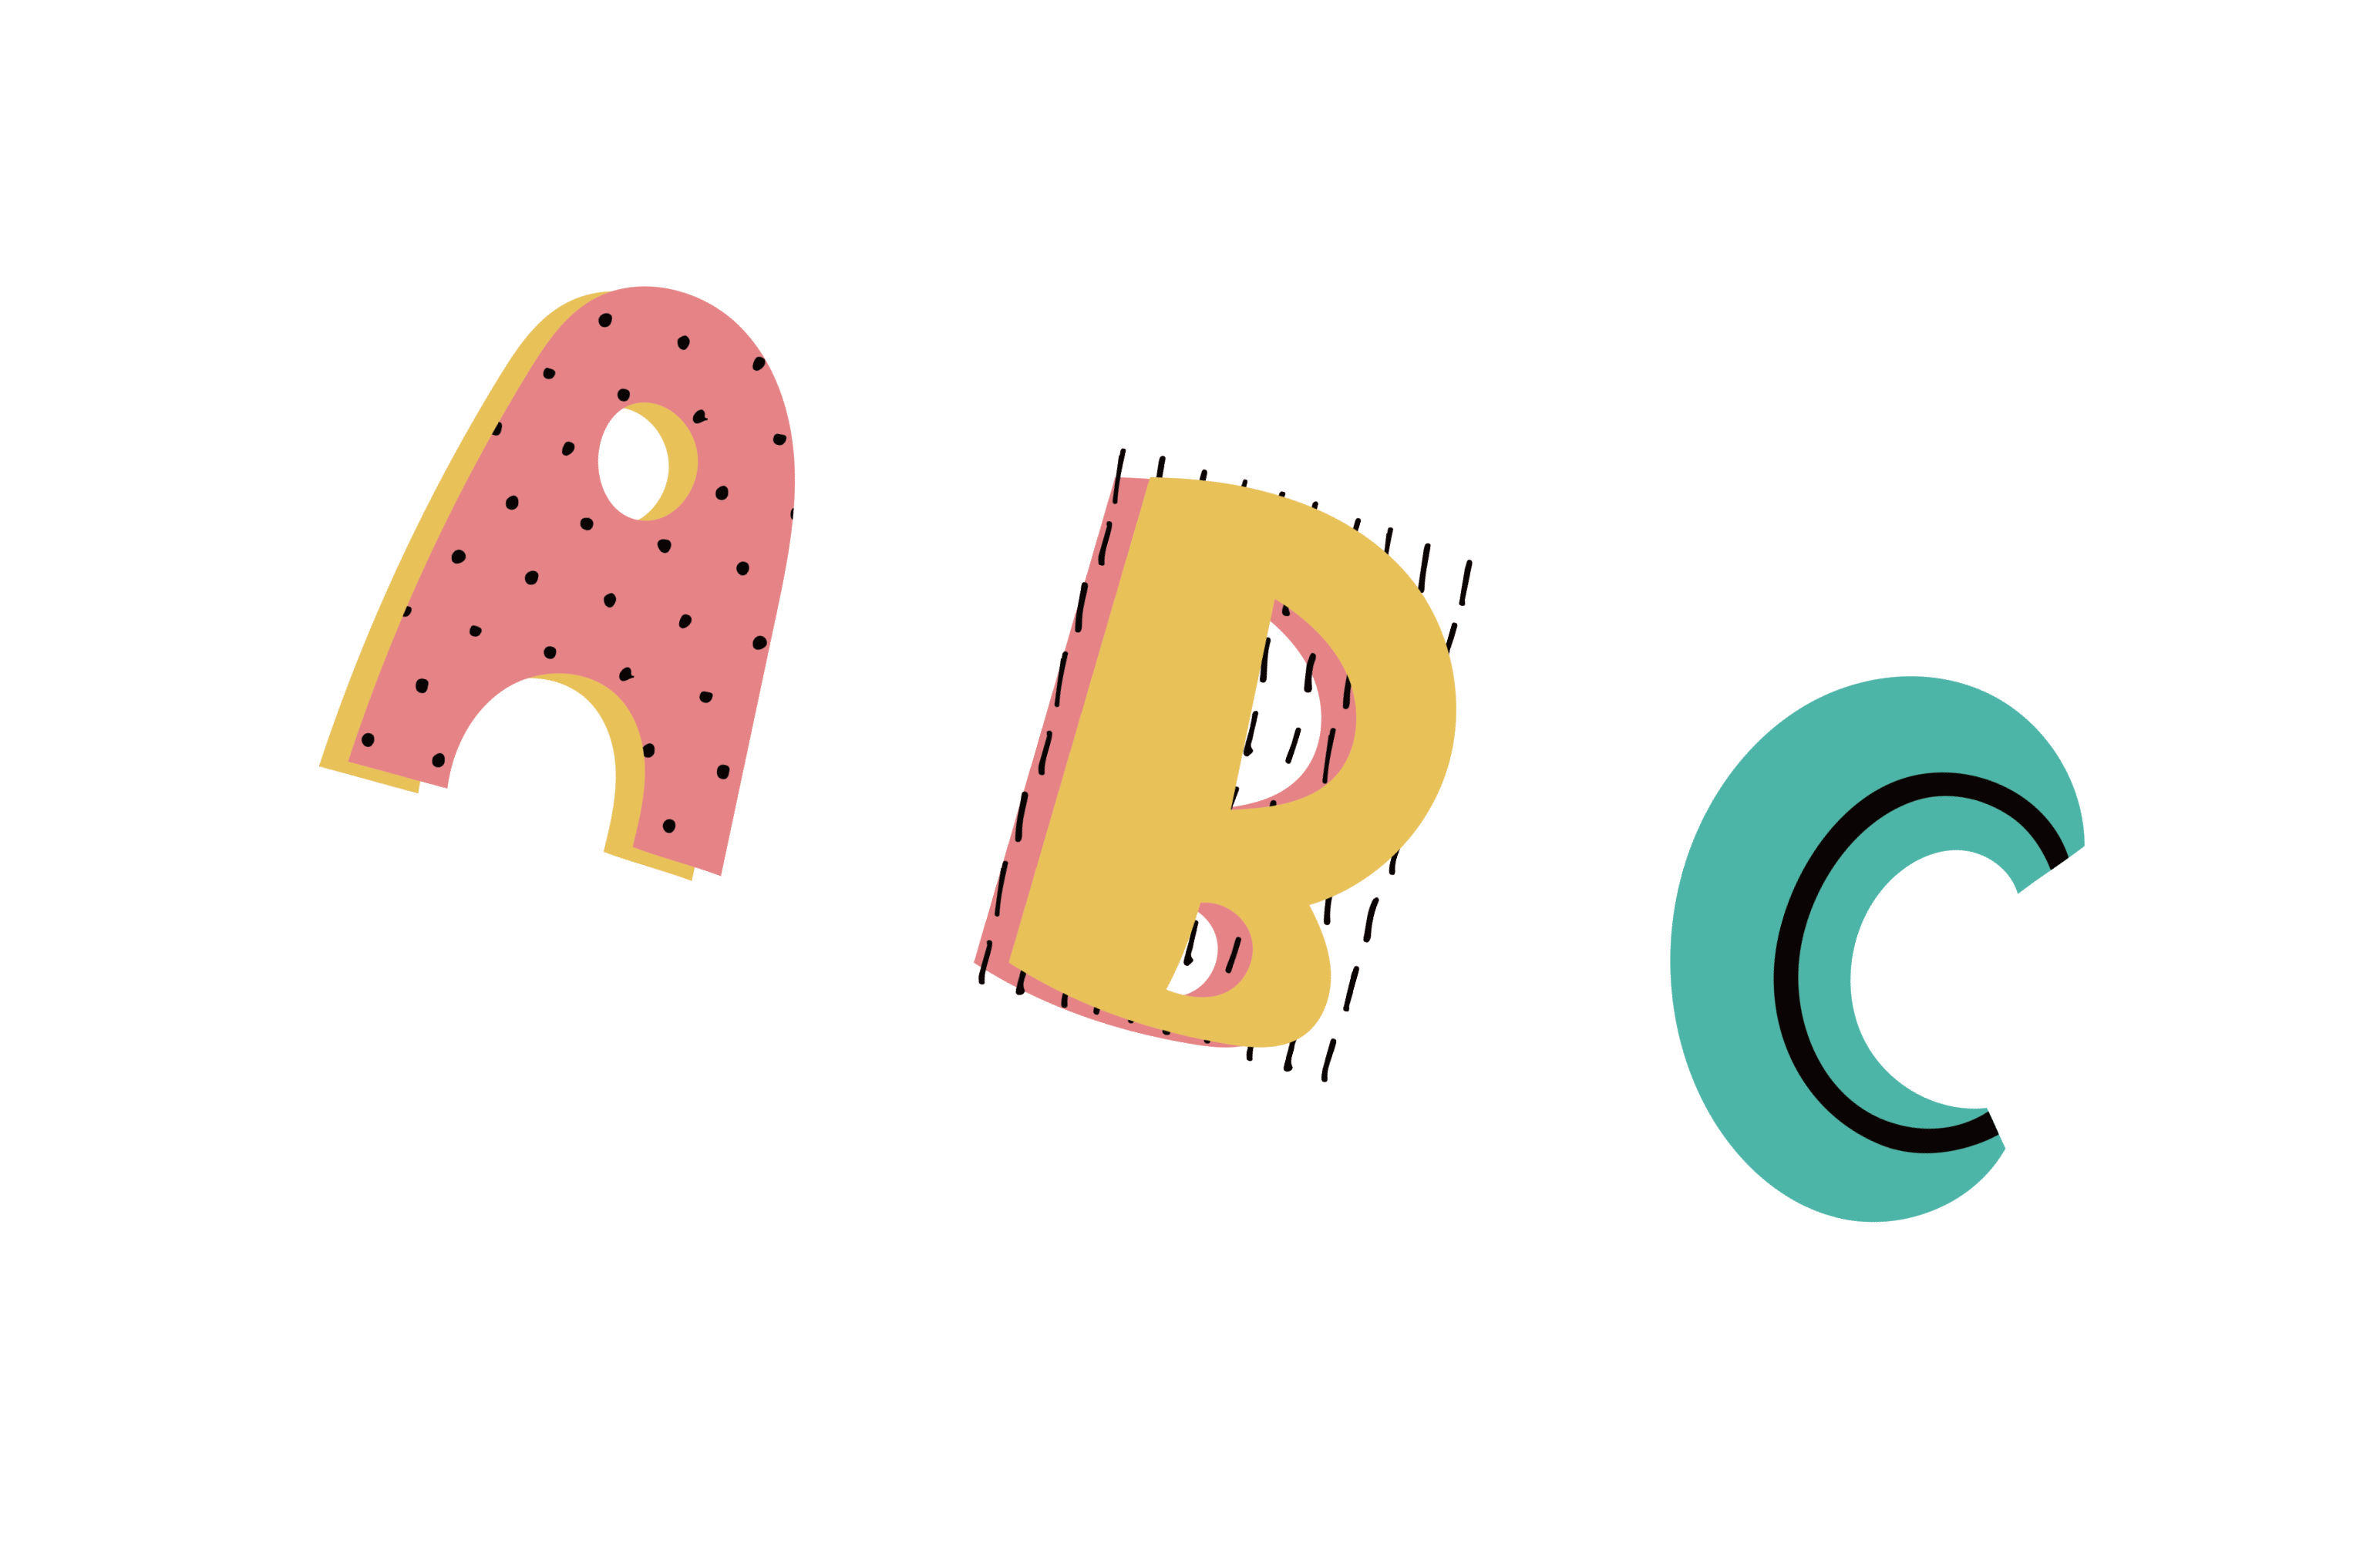Congratulations! 祝贺您！ Happy birthday! 生日快乐！ Happy new year! 新年快乐！ Merry Christmas! 圣诞快乐！ Have a nice holiday! 假日快乐！
Wish you every success! 祝您成功！

猜猜我是谁
I am black and white. I give milk.我是黑白色的。我供给牛奶。
Guess who I am. It’s me, the cow!猜猜我是谁。是我，奶牛！
I have a red comb. I lay eggs.我有一个红色的鸡冠。我孵蛋。
Guess who I am. It’s me, the hen!猜猜我是谁。是我，母鸡！

滑冰
妈妈买了我一双冰鞋鞋子在我的第五个生日。 从那时起，我爱好滑冰。 它不仅使我越来越加强，而且帮助我知道生活许多真谛。 我知道摔倒是正常的，并且，如果只有你能摔倒后再站起来，就是非常好!

Mom bought me a pair of skating shoes at my fifth birthday. From then on, I developed the hobby of skating. It not only makes me stronger and stronger, but also helps me know many truths of life. I know that it is normal to fall, and if only you can get on your feet again and keep on moving, you are very good!

